Revenue Decline Analysis
Nahum Ghebrehiwet
January 2026

Abstract:
As technology continues to evolve throughout the 21st century, businesses have increasingly utilized modern software to maximize profits and achieve business objectives. It has become increasingly necessary for businesses to utilize software programs such as Excel and SQL to maintain a competitive edge against their competitors. The FoodHunter dataset is an SQL file that includes crucial information about price, quantity sold, and date of transaction across multiple restaurants. When analyzing the order table, there is a monthly decline in revenue from June to September 2022. The goal of this paper is to find suitable methods to address the decline in revenue.
Data:
The data is a FoodHunter SQL database file that includes 6 tables (customers, drivers, food items, orders, order items, and restaurants). The order table includes the price and quantity of all the items sold from June to September 2022. The columns of interest include order id, total price, delivery fee, discount, final price, and customer rating.
Methodology:
The tool used in the data analysis is SQL. The visualizations were made using Microsoft BI.
To understand revenue trends, a query was conducted showing total revenue for each month. Each month a number is assigned, with June being number 6, July being 7, and so on.

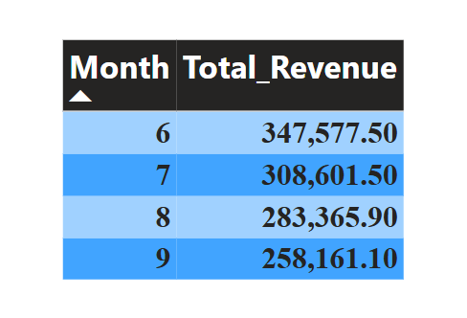
When looking at this table, the month of June has the highest total revenue, and the month with the second-highest revenue is July. The month with the lowest revenue is September. The table shows a consistent downward trend in total revenue across multiple months.

Solutions:
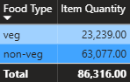

The table shows the total item quantity for veg (vegetarian) and non-veg (non-vegetarian). Non-vegetarian orders are nearly triple that of vegetarian orders. One potential solution is prioritizing non-vegetarian products, as this represents a larger share of FoodHunter customers.

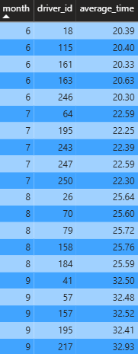
The table above shows the average delivery time for drivers across 3 months. Just like the first table, the months are represented numerically. The trend to notice is that the average time is increasing across multiple drivers. There could be multiple reasons for this that are beyond the control of any business, such as recent construction or school starting in August. It is also possible that some solutions could help decrease the delivery time, such as implementing route optimization software. An example of this is Routific, which is an AI-powered route optimization software for food and beverage companies. The software optimizes the best route for drivers based on driver schedules, traffic constraints, time windows, and several other variables.

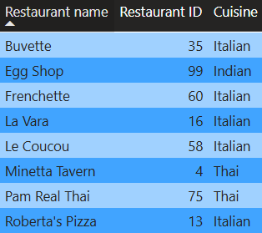

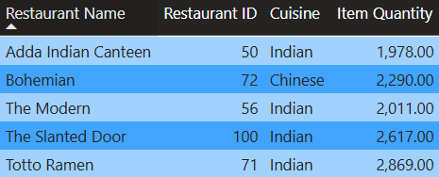
The table above shows all the following restaurants that have no orders placed. Most of the restaurants that don’t have any orders placed are Italian cuisine. This is likely a result of a market surplus where the quantity supplied is greater than the quantity demanded. A solution is to focus less on unprofitable restaurants and allocate more resources to restaurants with greater demand.

The table above shows the restaurants with the top 5 most orders placed. Almost all of the restaurants that have the highest number of orders serve Indian cuisine.

Conclusion:
The goal of this research was to analyze the fall in revenue in the FoodHunter data and figure out potential solutions. To improve revenue output, it is essential to conduct diligent data analysis and utilize the latest software programs. Potential solutions include providing options that consumers demand more, such as non-vegetarian meals and Indian Cuisine. Restaurant owners can also improve delivery by implementing the latest route optimization software to decrease time.
Limitations:
There were multiple limitations when conducting this analysis. The data does not include all the factors that affect the demand for restaurants. This includes, in detail, the price of competitors or consumer expectations in the short term. It is also important to emphasize that this analysis focuses on revenue.

